Predictive Analysis of Student Depression Using Supervised Machine Learning Algorithms.
Authors: [1.HABIMANA Vedaste,2.MUSABYIMANA Jean DAMOUR,3.NIYIGENA Ange Aime] Affiliation:[ "AFRETEC Training Program, University of Rwanda"]
Abstract: Mental health among students is a growing concern, necessitating data-driven approaches for early identification. This study evaluates various machine learning algorithms to predict depression based on demographic, academic, and lifestyle factors. Using a comprehensive dataset of 27,901 students, we compared Logistic Regression, Decision Tree, K-Nearest Neighbors (KNN), Random Forest, and Gradient Boosting models. Our findings indicate that Logistic Regression and Gradient Boosting achieved the highest performance, with accuracies of 84.19% and 84.02% respectively.
Aims and Scope of the Study:
This study aims to analyze factors associated with student depression and develop machine learning models capable of predicting depression using demographic, academic, lifestyle, and psychological variables.
Contents
1. Introduction 2
2. Materials and Methods 3
2.1. Dataset Description 3
2.2. Data Preprocessing 4
2.3. Data Splitting 4
3. Results 6
3.1. Model Performance Evaluation 6
3.1.1.The performance was evaluated using Accuracy, Precision, Recall, and F1-score metrics. 6
3.1.2.ROC–AUC Performance Comparison 6
3.2. Feature Importance 7
4. Discussion 10
5. Conclusions 10
6.Recommendations 10
7.Appendix 11
8.References 11

1. Introduction
Student depression is a rising global issue that has a substantial impact on academic achievement, emotional health, and general quality of life. Due to stigma and inadequate mental health knowledge, many students put off getting professional care despite experiencing psychological anguish as a result of lifestyle issues, financial difficulties, and academic pressure. This delay emphasizes the necessity for early detection techniques and raises the possibility of serious mental health consequences.
The development of data-driven solutions for the early detection of depression using structured student data has been made possible by advances in machine learning. Survey-based datasets, in contrast to social media-based methods, enable more accurate risk factor interpretation and useful application in educational contexts. This study used a structured student mental health dataset to predict depression using a variety of machine learning algorithms. To determine important predictors, the model's performance was assessed using ROC-AUC analysis, confusion matrix metrics, and feature importance evaluation.
The results show that machine learning methods can successfully assist early student depression screening and offer insightful information for mental health intervention and prevention initiatives in educational settings.

2. Materials and Methods

2.1. Dataset Description
The study's dataset includes extensive data on students' mental health and related variables. It contains information on demographics, pressures from job and school, lifestyle choices, and psychological markers.
The variables include:
- Gender, Age, City, Profession
- Academic Pressure, Work Pressure
- CGPA;cumulative grade point average.
- Study Satisfaction, Job Satisfaction
- Sleep Duration, Dietary Habits
- Work/Study Hours
- Financial Stress
- Family History of Mental Illness
- Have you ever had suicidal thoughts?
- Depression (target variable)

2.2. Data Preprocessing
Data preprocessing was performed using Python to ensure data quality and consistency. The preprocessing steps included:
Replacing missing values by median in financial stress variable.
Encoding of categorical variables
Verification of class balance in the target variable
These steps ensured that the dataset was suitable for machine learning model training and evaluation.
A structured student mental health dataset was analyzed using Python. Data preprocessing, exploratory data analysis, and supervised machine learning techniques were applied. Multiple classification models Logistic Regression, Random Forest, Gradient Boosting, Decision Tree, and K-Nearest Neighbors were trained and evaluated using ROC–AUC analysis and confusion matrix metrics.

2.3. Data Splitting
After preprocessing, the dataset was divided into training and testing subsets using the train_test_split() function from the scikit-learn library. A 70:30 split ratio was applied, with 70% of the data used for training and 30% reserved for testing. The random_state parameter was set to 42 to ensure reproducibility.
Logistic Regression:Confusion matrix
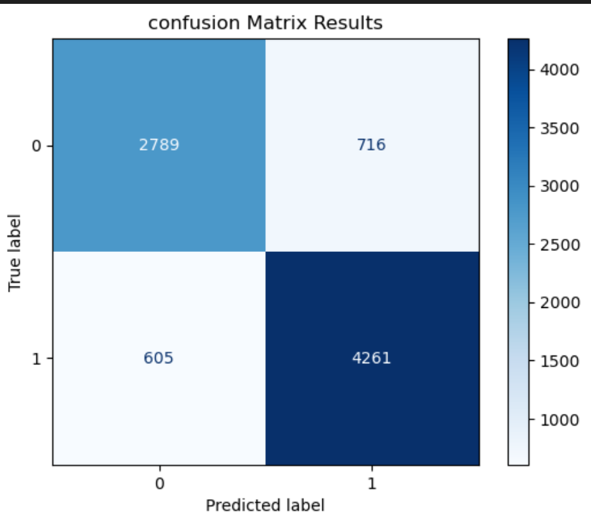
Figure1: confusion matrix
The confusion matrix reveals that the model performs particularly well in identifying students experiencing depression, as reflected by the high true positive count (4,261. This characteristic is highly desirable in mental health screening applications, where failing to identify a depressed individual (false negative) can have serious consequences.
Although some false positives (716 cases) were observed, this trade-off is acceptable in early detection systems, where it is preferable to flag at-risk students for further assessment rather than overlook those in need of support. The relatively lower number of false negatives (605 cases) further demonstrates the model’s effectiveness in minimizing missed depression cases.

3. Results

3.1. Model Performance Evaluation

3.1.1.The performance was evaluated using Accuracy, Precision, Recall, and F1-score metrics.
Model | Accuracy | Precision | Recall | F1-score | ROC AUC
Logistic Regression | 0.8419 | 0.8557 | 0.8756 | 0.8656 | 0.9168
Gradient Boosting | 0.8402 | 0.8519 | 0.8777 | 0.8646 | 0.9182
Random Forest | 0.8340 | 0.8491 | 0.8688 | 0.8589 | 0.9095
Decision Tree | 0.7509 | 0.7935 | 0.7725 | 0.7828 | 0.7467
KNN | 0.7412 | 0.7554 | 0.8203 | 0.7866 | 0.8004
Table 1Comparizon of performance of model

3.1.2.ROC–AUC Performance Comparison

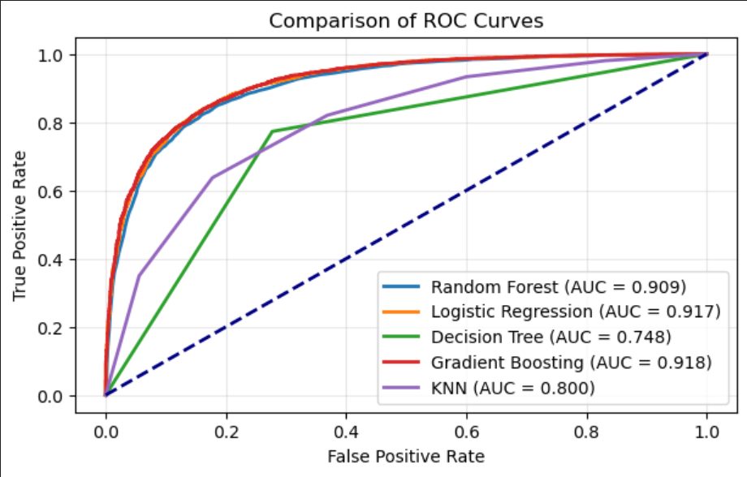
Figure 2:ROC-AUC
Gradient Boosting achieved the highest performance with an AUC of 0.918, followed closely by Logistic Regression (AUC = 0.917) and Random Forest (AUC = 0.909).

3.2. Feature Importance
Analysis of the models revealed that features such as Academic Pressure, Financial Stress, and Study Satisfaction played significant roles in predicting the target variable, "Depression".
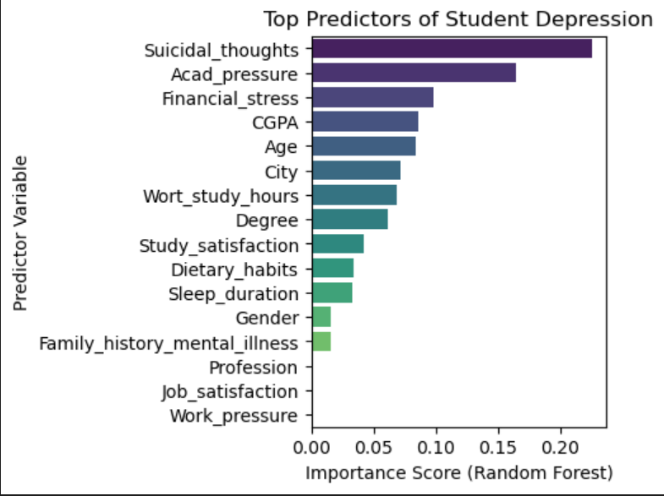
Figure3:Top predictors od depression
Suicidal thoughts were found to be the most important predictor with the greatest importance score, according to the analysis. This suggests that adolescents who report having suicide thoughts are significantly more likely to be diagnosed as depressed. This result is consistent with psychological studies that has shown suicidal thoughts to be a crucial sign of severe depression.
Academic strain was the second most significant factor, demonstrating the close connection between student mental health and academic stress. Exam stress, high academic demands, and performance expectations seem to be important factors in the emergence of depression symptoms. This finding corroborates other research that found academic strain to be the main source of stress in higher education settings.
The third most significant predictor was financial stress, highlighting the psychological effects of financial difficulties on students. Emotional anguish and depressed symptoms can be greatly exacerbated by financial instability, worries about tuition, and restricted access to resources.
It is interesting to note that age and CGPA showed moderate importance, indicating that while maturity and academic achievement may have an impact on mental health, psychosocial stressors are more important. The idea that depression is more strongly associated with emotional and environmental factors than with academic results is further supported by the comparatively lower significance of CGPA.
Contextual and workload-related implications were evident in the lower but non-negligible contributions of variables including city, work/study hours, and degree program. Indirect but significant influences on mental health were suggested by the minor importance of lifestyle-related characteristics, such as study satisfaction, food habits, and sleep duration.
Gender, family history of mental illness, occupation, job happiness, and work pressure, on the other hand, contributed very little to the predictive model. Although these variables are frequently covered in the literature on mental health, their lesser significance in this dataset raises the possibility that additional significant stress-related factors may mediate their effects.

4. Discussion
The findings show that ensemble techniques (Gradient Boosting) and linear models (Logistic Regression) performed comparably in this situation. The good performance of Logistic Regression indicates a clear linear association between the observed stressors and the likelihood of depression in this student group, even though tree-based models are frequently recommended for complicated datasets.

5. Conclusions
This study demonstrated that machine learning can predict student depression with a high degree of accuracy (84.19%). Critical signs include things like financial hardship and academic pressure. In order to give at-risk students early support, future research should concentrate on integrating these models into university counseling systems.

6.Recommendations
Educational institutions should include machine learning to detect student having depression early. Forming mental health clubs through letting students counseling each other, and inviting mentors specialized in mental health to have discussions with students. Institutions can also use strategies like more flexible work schedules and improved financial and academic advising to reduce financial and academic stress.

7.Appendix
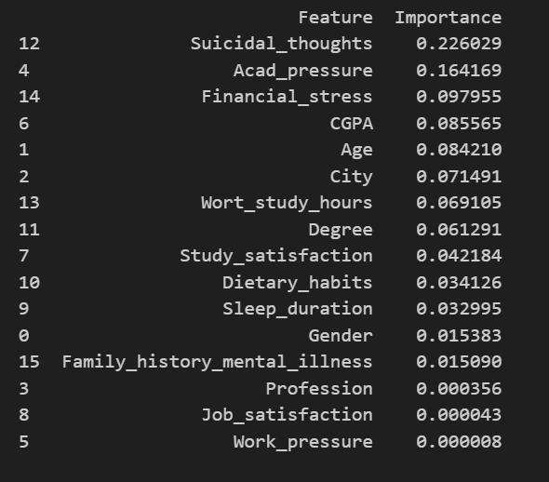
Table 2:Top predictors of depression

8.References
- Student Depression Dataset. Available online: https://www.kaggle.com/datasets/adilshamim8/student-depression-dataset.

